**Hypothesis Assignment Day 10**

**Step 1- Launching**

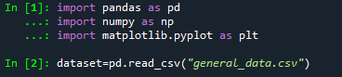

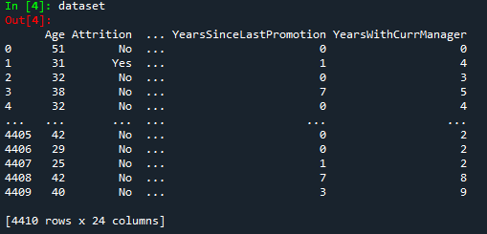

**Step 2- Data Treatment**

Removed Null and Duplicate Values

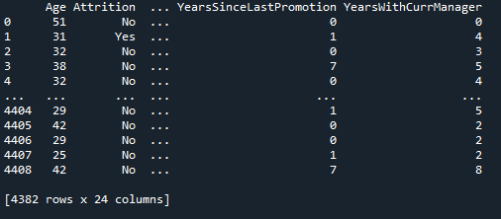

Created two dataframes-

* dataset1= attrition Yes
* dataset2= attrition No

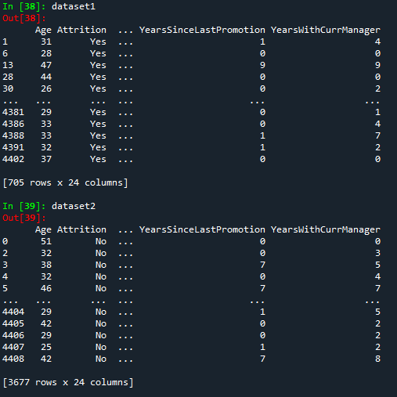

Data of Employees who left the Company-

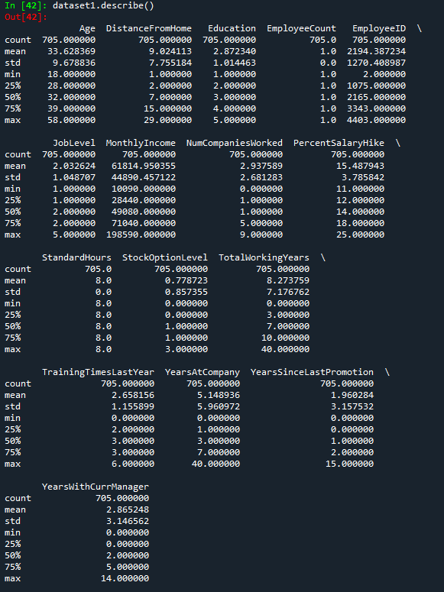

Data of Employees who did not leave the Company-

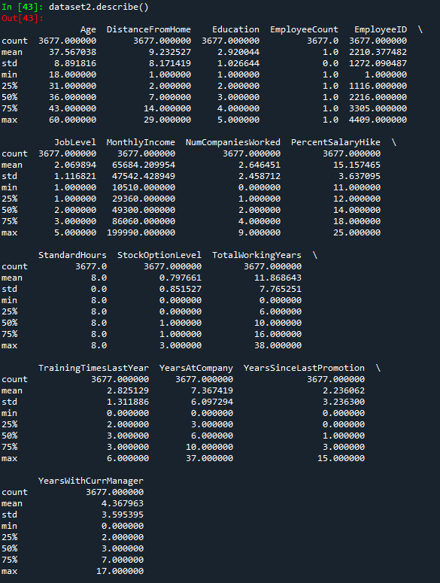

**Hypothesis on the above study-**

1. Employees with average age 33 has more chance of attrition
2. There is significant relation between age and gender
3. More than 50 % employee left job had type 1 or 2 type job
4. Number of Companies worked also has no effect on attrition.
5. Employees with Total Working Years < 10 have more chance of attrition.
6. Employees with ﻿Years at Company < 7 have more chance of attrition.
7. Employees with ﻿Years with Current Manager < 3 have more chance of attrition.
8. Training Times Last Year also has no effect with attrition.
9. Percent Salary Hike also has no effect on attrition.